

WOLKITE UNIVERSITY

COLLEGE OF COMPUTING AND INFORMATICS

DEPARTMENT OF SOFTWARE ENGINEERING

PROJECT ON

**AUTOMATED COURSE REGISTRATION & RESULT PROCESSING SYSTEM**

BY

|  |  |  |
| --- | --- | --- |
| No | NAME OF THE STUDENTS | IDNO |
| 1 | ABEBAYEHU ALARO | CIR/242/10 |
| 2 | HONEY ASRAT | CIR/276/10 |
| 3 | NUH ASRAR | CIR/294/10 |
| 4 | ADUGNAW TESHALE | CIR/244/10 |
| 5 | RUTH KASSAHUN | CIR/298/10 |

WOLKITE UNIVERSITY, WOLKITE, ETHIOPIA

10 JANUARY 2020

TABLE OF CONTENTS

**LIST OF FIGURES** vi

**LIST OF TABLES** vi

**CHAPTER ONE** 2

**1.** **INTRODUCTION** 2

**1.1.** **Background of the Organization** 3

**1.2.** **Statement of the Problem** 3

**1.3.** **Objectives of the Project** 4

**1.3.1.** **General Objective** 4

**1.3.2.** **Specific Objective** 4

**1.4.** **Feasibility Analysis** 4

**1.4.1.** **Technical Feasibility** 5

**1.4.2.** **Operational Feasibility** 5

**1.4.3.** **Economic feasibility** 5

**1.5.** **Scope and Limitation of the Project** 5

**1.5.1.** **The scope of the Project** 6

**1.5.2.** **Limitation of the Project** 6

**1.6.** **Significance of the Project** 6

**1.7.** **Beneficiary of the Project** 7

**1.8.** **Methodology of the Project** 7

**1.8.1.** **Data Collection Tools/Techniques** 8

**1.8.2.** **System Analysis and Design** 8

**1.8.3.** **System Development Model** 9

**1.8.4.** **System Testing Methodology** 9

**1.8.5.** **Development Tools and Technologies** 10

**1.8.** **Budget and Time Schedule of the Project** 12

**1.8.1.** **Budget of the Project** 12

**1.8.2.** **Time Schedule of the Project** 13

**CHAPTER ONE** 14

**2.** **INTRODUCTION** 14

**1.9.** **Background of the Organization** 15

**1.10.** **Statement of the Problem** 15

**1.11.** **Objectives of the Project** 16

**1.11.1.** **General Objective** 16

**1.11.2.** **Specific Objective** 16

**1.12.** **Feasibility Analysis** 16

**1.12.1.** **Technical Feasibility** 17

**1.12.2.** **Operational Feasibility** 17

**1.12.3.** **Economic feasibility** 17

**1.13.** **Scope and Limitation of the Project** 17

**1.13.1.** **The scope of the Project** 18

**1.13.2.** **Limitation of the Project** 18

**1.14.** **Significance of the Project** 18

**1.15.** **Beneficiary of the Project** 19

**1.16.** **Methodology of the Project** 19

**1.16.1.** **Data Collection Tools/Techniques** 20

**1.16.2.** **System Analysis and Design** 20

**1.16.3.** **System Development Model** 21

**1.16.4.** **System Testing Methodology** 21

**1.16.5.** **Development Tools and Technologies** 22

**1.9.** **Budget and Time Schedule of the Project** 24

**1.8.3.** **Budget of the Project** 24

**1.8.4.** **Time Schedule of the Project** 25

**CHAPTER TWO** 26

**DESCRIPTION OF THE EXISTING SYSTEM** 26

**2.1.** **Introduction of Existing System** 26

**2.2.** **Users of Existing System** 26

**2.3.** **Major Functions of the Existing System** 28

**2.4.** **Forms and Other Documents of the Existing Systems** 28

**2.5.** **Drawbacks of the Existing System** 32

**2.5.1.** **Performance** 32

**2.5.2.** **Economic problem** 32

**2.5.3.** **Efficiency:-** 32

**2.5.4.** **Searching Problem:-** 33

**2.5.5.** **Security Problem:-** 33

**2.6.** **Business Rules of the Existing System** 33

**User validation:** 33

**Grade Report:** 33

**Accountability of the users:** 33

**Description of the Grading System** 34

**Student Academic Achievements** 35

**Academic Standing of Undergraduate Students** 35

**Modular Courses** 35

**First Year Students** 36

**Second and Higher Class Year Students** 36

**Discretionary Probation** 37

**CHAPTER THREE** 38

**3. PROPOSED SYSTEM** 38

**3.1.** **Functional Requirements** 38

**User Module** 38

**Registrar Staff (Admin)** 38

**Dean of College (DOC)** 38

**Head of Department** 39

**Student** 39

**Staff** 40

**Control and Check Module** 40

**Registration Module** 40

**Result Processing Module** 41

**Report Module** 41

**3.2.** **Non-functional Requirements** 41

**3.2.1.** **User Interface and Human Factors** 41

**3.2.2.** **Hardware Consideration** 42

**3.2.3.** **Security Issues** 42

**3.2.4.** **Performance Consideration** 43

**3.2.5.** **Error Handling and Validation** 43

**3.2.6.** **Quality Issues** 43

**3.2.7.** **Backup and Recovery** 43

**3.2.8.** **Physical Environment** 44

**3.2.9.** **Documentation** 44

**CHAPTER FOUR** 45

**4.** **SYSTEM ANALYSIS** 45

**4.1.** **System Model** 45

**4.1.1.** **Use Case Model** 45

HOD 46

Admin 47

**Student** 47

Staff 47

**4.1.1.2.** **Use Case Description** 50

**4.2.2.** **Data Dictionary** 55

**4.3.** **Dynamic Model** 56

**4.3.1.** **Sequence Diagram** 56

**4.3.2.** **Activity Diagram** 59

**4.3.3.** **State Chart Diagram** 62

**CHAPTER FIVE** 65

**5.** **SYSTEM DESIGN** 65

**5.1.** **Design Goals** 65

**Accessibility** 65

**Integrity** 65

**Scalability** 65

**Availability** 66

**Throughput** 66

**Robustness** 66

**Security** 66

**Maintenance** 66

**5.2.** **Design Trade-offs** 67

**Security vs Usability** 67

**Functionality vs Usability** 67

**Performance vs portability** 67

**5.3.** **Proposed System Architecture** 68

**5.3.1.** **Subsystem Decomposition and Description** 68

**Student subsystem** -- responsible for handling action that Studentperforms 69

**Staff subsystem** -- responsible for handling action that Staffperforms 70

**5.3.2.** **Hardware/Software Mapping** 72

**5.3.3.** **Detailed Class Diagram** 74

**5.3.4.** **Persistent Data Management** 76

**5.4.** **User Interface Design** 78

**REFERENCES** 81

# **LIST OF FIGURES**

Figure 1.1: time schedule of the project 11

# **LIST OF TABLES**

Table 1.1:software tools ………………………………………………………………………………………………………………….10

Table 1.2:hardware tools…………………………………………………………………………………………………………………10

Table 1.3:budget of the project……………………………………………………………………………………………………….11

# **CHAPTER ONE**

# **INTRODUCTION**

Automated course registration and result processing system is a software that facilitates the student’s course registration and processing of examination result. It will build in an automated information system capability that will ease the stress and enhance all the activities involved in course registration and result processing.

The occurrence of examination and assessment irregularities can seriously damage public confidence in the validity and legitimacy of examination and assessment results and should be dealt with as a matter of urgency within the judicial framework established for this purpose.

There are different computer programs in different tertiary institutions for computing examination results. However, beyond examination result computation, not many programs in use provide multilevel aggregated data of student population and academic progress at various stages of studentship. The need for data use to inform administrative decisions in tertiary institutions have been emphasized for the purpose of better planning.

Almost every section of the educational system requires information processing. With the deployment of a good information system, wear and tear occasioned during data retrieval and handling, and sometimes loss is greatly minimized. Data sharing is less difficult and reproduction becomes a lot cheaper. Furthermore, information system when employed to the educational sector, prompts the following:- prompt access to students’ personal and course information, instant student information updating, automatic computation of the Grade Point Average (GPA), monitoring of failed courses, quick production of result, storing course information such as course code, course description, course unit and scores for the purpose of GPA computation, and producing user-friendly data entry screens for ease of use.

It is unfortunate that most universities in Ethiopia still adapt the manual system of course registration and examination result processing. Wolkite University is one of the third generation universities in Ethiopia. Let us look some problems of the manual system of course registration and examination result processing in Wolkite University. The errors associated with the existing manual method of results computation in Wolkite University make it not only desirable but imperative that automated approach be used to the full in measuring students’ progress. The manual method being employed suffer a number of set-backs. It makes the process to be time-consuming and prone to error. It leads to examination results being published late, sometimes with wrong grades being entered and students’ grade point averages being wrongly computed. It also leads to loss or misplacement of student’s result. In some cases, it leads to incoherent course registration

## **Background of the Organization**

Wolkite University is one of the third generation universities in the country. As higher education institution besides of teaching learning participating on research, projects and community services on the major identified prioritize problem areas are the concern of universities. The University gives educational services for regular students as well as extension programs for the people who live in Wolkite town, neighboring cities and other parts of the country. The University is also works to become research institute for different areas of field of studies. In the University there are different activities that are performed. Among those activities, Wolkite University Course Registration & Result Processing System is one of the major management activities which is performed to register students and show their results. In this process there is a potential problem associated with the Course Registration & Result Processing. So the team initiated this project to identify and analyze those problems and to put possible remedies (solutions).

## **Statement of the Problem**

The current Course Registration and Result Processing System has many problems that are illustrated below.

1. **Performance**

Since the registrar office performs registration, grade submission, slip, grade report, add/drop courses, searching and data retrieving mechanism of the system manually, its response time is low.

1. **Economy**

Since the system currently uses manual system, it is not economically sufficient i.e. there are high cost of creating physical archives and buying resources (paper for slip, grade report and related things), high cost of managing and archiving documents in physical environment, and high cost for employers.

The other problems associated with the current Course Registration and Result Processing System are:

* It does not have a unified database.
* Student’s test and exam scores may be entered wrongly when manually done.
* There is no structure that compels students to register all outstanding courses before proceeding to the recent ones.
* It is very cumbersome to manually reconcile all registered courses from different  
  files sources into their work sheet for the purpose of result computation.
* It is vulnerable to natural and manmade disasters, and security cases.

## **Objectives of the Project**

### **General Objective**

The main aim of this project work is to provide an Automated Course Registration and Result Processing System that prompts correct course registration, shows correct students result and keep all result information of a student.

### **Specific Objective**

* Study and analyze the existing system
* Design and develop a unified database system that coordinates course registration and result processing and store data.
* Design and develop components of course registration.
* Design and develop components of result processing.
* Test and evaluate the proposed system.
* Maintain and deploy the final product of the project.

## **Feasibility Analysis**

The feasibility study is used to investigate the proposed system in multiple dimensions. It is used to indicate whether the system feasible or not. The feasibility study is an important phase in both the research and software development process. It enables the developer to have an assessment of the product being developed. It refers to the feasibility study of the product in terms of outcomes of the product, operational use and technical support required for implementing it.

### **Technical Feasibility**

Technical feasibility is the measure of the practicality of the specific technical support and the availability of technical resources and expertise to use the system. The technology that we use to develop the proposed system is available within the given resource constraints (i.e., budget, schedule...) and mature enough to be easily applied to our problem. It is also easy to maintain and is very much adaptable for change. Our development team has the required knowledge to develop the functionalities of the system. So, the system will be technically feasible.

### **Operational Feasibility**

It determines how the proposed system will satisfy the organizations need and it also offers secure, accurate and efficient system to the organization. The current system is very time consuming since it performs operations manually but the proposed system is automated as result its response time is low. The system performs all of its tasks in a user-friendly manner and it focus on security issues. In which, anyone without an advanced technical background can use the system. The system is also compatible with all operating systems and web browsers. So, the project is operationally feasible.

### **Economic feasibility**

Economic feasibility is the process of identifying the financial benefits and costs associated with the project being developed. We are using a free hosting server and it doesn’t need a lot of resources. The manual system requires many workers to handle all the works of the organization. This implies that the agency is requested to pay salary to those workers involved in that work flow and the cost is too much. In contrary, the proposed system needs a few workers and replace the rest workers with computers. The proposed system is efficient i.e. the development of the system requires a minimum amount of cost within a short time. So, the project is economically feasible. The estimated cost of resources that we use to develop this project shown in table 1.3.

## **Scope and Limitation of the Project**

Project scope is the part of project planning that involves determining and documenting a list of specific project goals, deliverables, features, functions, tasks, deadlines and ultimately costs.

A limitation is a restriction on the applicability of a project that may arise from the inability to obtain sufficient appropriate evidence about a component in the financial statements

### **The scope of the Project**

This research work will concentrate on student registration, course registration, academic transcript, and result processing system in Wolkite University and can be extended to other Universities.

### **Limitation of the Project**

Our system does not include the following systems

* Student placement
* Class scheduling
* Exam scheduling

## **Significance of the Project**

The significance of this study is to design and implementation of Student Examination Result Processing System is

* To achieve the speedy registration process and results processing
* To eliminate error due to manual processing and to provide security measure to check student mischievous act of changing marks on the result sheet.
* The new system would enhance the result processing performance as it will reduce delay in computing student’s result.
* Increased accessibility to resources without geographic location or organizational affiliation.
* Users can gain access to the information at any time.
* Information resources can be searched easily (like course information’s).
* It save Space which reserved by rooms.
* Improve the data sharing (uploading and downloading) from one sub-system to another subsystem.
* The authorized access to information resources files of the system is more advanced. This means secured login to the system will be developed.
* Resources and time saving in system operation and service provision is one of the major benefits.

## **Beneficiary of the Project**

1. **To the Students**

Students stand to greatly benefit from this project work. The new system will enable students to see all failed courses, give them the opportunity to register and rewrite them on time, to view their exam result and grade report. There would be reduced case of overstay.

1. **To the Faculty Members**

Through this system, the faculty members can provide all the necessary information and resource material to their students and also be able to get the student information from the website. Result computation would be easier and convenient for the exam officers as all result information will be kept and generated from the system.

1. **To the University’s Registrar Office**

Our system has a great deal on the issues concerned with registration by providing necessary information, easing the work and the working environment, and others. The registrar office gets different functionality from the system these are:

* Manages student’s data easily and efficiently.
* Gives registration activity on time.
* Controls the readmission of students easily.
* Solves add/drop courses conflicts.
* Saving their time
* Reduce complexity

1. **Group beneficiaries**

The project has initiated our team to get knowledge of how to develop the required system application. While struggling with some difficulties, the team got a lot of experiences of solving problems.

## **Methodology of the Project**

In order to accomplish this project on time and within the cost, we would follow different procedures which are described below.

### **Data Collection Tools/Techniques**

Data collection methodology is the way of gathering relevant data/information to study problems of the current system.

1. **Interview**

It is a technique of data collection and gives the needed information verbally in a face-to-face relationship. Interview is more flexible tool, so we collect our data by interviewing registrar office, department heads and staffs.

1. **Observation*:***

It is a useful data collection technique that assists the team to assess the manual system by participating or watching in the real work and forms using in the existing manual system.

1. **Document analysis**

The team analyze forms and documents of Wolkite University related to course registration and result processing system and some related previously done projects which are very important to develop our project. During the analysis of documents, we give special consideration to those documents which can bring more features to our system.

### **System Analysis and Design**

In the system analysis and design phase of a project we use the object oriented approach that examines requirements from the perspective of the class and objects found in the problem domain. The reasons that we use the object oriented system analysis and design are:

* + Easier to adapt to changing requirements, easier to maintain, more robust and promotes greater design and code use.
  + High level of abstraction
    - Abstraction at object level (since objects encapsulate both data (attribute) and function (method).
  + Seamless transition among different phases of software development
  + Encourage good programming techniques
    - Changing one class cannot affect the other
    - Nothing is magical
  + Promotion of reusability
    - Because objects are directly modeled from real world problem domain each object stands by itself or within a small circle of peers(other objects)
    - Inheritance(only difference and enhancement is needed to be designed and coded)

### **System Development Model**

We are going to develop the proposed system using Incremental Model because it has the following key points.

Incremental Model: It is one of the types of Software Development Life Cycle (SDLC), where software product is being developed, on incremental basis.

* Involves multiple times execution of the development process, using waterfall model strategy, to deliver the software versions in the form of new releases, after the completion of each development cycle.
* Requirements, on priority basis, are added to each increment, until all of the requirements are fused in the software product.
* Ensures software development along with its maintenance.
* Risks and defects are explored and corrected, within each iteration.
* Flexible & less, to continuously meet the incoming requirements.

### **System Testing Methodology**

* 1. **Unit testing**

We will use the unit testing to do the following actions

* To check whether the return type of the functions is correct.
* To check how the sub procedures or functions are called correctly.
* To check input values and correct output data.
* To optimize algorithm and performance
  1. **Integration Testing**

A proposed software will be developed by different individuals with each one handling a particular module. Since the way that each developer uses logic tends to differ from one another, we use integration testing to combine and test all the modules and perform complete software testing. We will use integration testing to do the following actions:

* To make sure that the software modules work together appropriately and as per the expectation of the testing team, when integrated with one another.
* To find errors in the interface of the software.
* To ensure that the various modules of the software work in unity.
* To verify the functionality, performance, and reliability between the integrated modules.
* To tackle issues related to inadequate exception handling.
  1. **System testing**

We will use the system testing to monitor and assess the behavior of the complete and fully-integrated software product or system, on the basis of pre-decided specifications and functional requirements. We will use the system testing to do the following actions:

* To test whether the product meets the quality standards or not.
* To validate system’s compliances with client’s functional, technical and business requirements.
* To perform end to end testing to prevent system failures and crashes during its implementation to the live environment.

### **Development Tools and Technologies**

A computer program that software developers use to create, debug, maintain, or otherwise support other programs and applications. The term usually refers to relatively simple programs, that can be combined together to accomplish a task, much as one might use multiple hand tools to fix a physical object. The most basic tools are a source code editor and a compiler or interpreter which are used ubiquitously and continuously.in our system use the following development tool.

#### **Frontend Technologies**

The user interface is developed using

* HTML
* CSS
* Bootstrap
* JavaScript

#### **Backend Technologies**

ASP.Net and SQL database used in developing and managing at the back-end. SQL database software will be used for persistent data and backend management will be done by ASP.Net.

#### **Documentation and Modeling Tools**

**Software tools**: are software installed on a computer for a different purpose from documentation up to the implementation. We describe in the following table 1.1

Table 1.1 software tools

|  |  |
| --- | --- |
| Software tools | Description |
| Microsoft Word 2016 | For documenting the corresponding deliverables associated with the project. |
| Edraw Max | For designing unified modeling language (UML) diagrams. |
| Adobe Photoshop | For design user interface. |

**Hardware tools**: the hardware tools that we are going to use to develop the proposed system are described under the following table

Table 1.2 hardware tools

|  |  |
| --- | --- |
| Hardware tools Description | Description |
| Computer (desktop or laptop) | For documentation and implementation. |
| CD or flash disk | For backup and storage. |

## **Budget and Time Schedule of the Project**

### **Budget of the Project**

Table 1.3 budget of the project

|  |  |  |  |
| --- | --- | --- | --- |
| Materials | Amount | Unit Price(Birr) | Total Price(Birr) |
| Paper | 1 pack | 200 birr | 200 birr |
| Photocopy Cost | 120 | 0.50 birr | 60 birr |
| Printing Cost | 60 | 1 birr | 60 birr |
| Pen | 20 | 10 birr | 200 birr |
| Total |  |  | 520 birr |

### **Time Schedule of the Project**

#### Figure 1.1 time schedule of the project

# **CHAPTER ONE**

# **INTRODUCTION**

Automated course registration and result processing system is a software that facilitates the student’s course registration and processing of examination result. It will build in an automated information system capability that will ease the stress and enhance all the activities involved in course registration and result processing.

The occurrence of examination and assessment irregularities can seriously damage public confidence in the validity and legitimacy of examination and assessment results and should be dealt with as a matter of urgency within the judicial framework established for this purpose.

There are different computer programs in different tertiary institutions for computing examination results. However, beyond examination result computation, not many programs in use provide multilevel aggregated data of student population and academic progress at various stages of studentship. The need for data use to inform administrative decisions in tertiary institutions have been emphasized for the purpose of better planning.

Almost every section of the educational system requires information processing. With the deployment of a good information system, wear and tear occasioned during data retrieval and handling, and sometimes loss is greatly minimized. Data sharing is less difficult and reproduction becomes a lot cheaper. Furthermore, information system when employed to the educational sector, prompts the following:- prompt access to students’ personal and course information, instant student information updating, automatic computation of the Grade Point Average (GPA), monitoring of failed courses, quick production of result, storing course information such as course code, course description, course unit and scores for the purpose of GPA computation, and producing user-friendly data entry screens for ease of use.

It is unfortunate that most universities in Ethiopia still adapt the manual system of course registration and examination result processing. Wolkite University is one of the third generation universities in Ethiopia. Let us look some problems of the manual system of course registration and examination result processing in Wolkite University. The errors associated with the existing manual method of results computation in Wolkite University make it not only desirable but imperative that automated approach be used to the full in measuring students’ progress. The manual method being employed suffer a number of set-backs. It makes the process to be time-consuming and prone to error. It leads to examination results being published late, sometimes with wrong grades being entered and students’ grade point averages being wrongly computed. It also leads to loss or misplacement of student’s result. In some cases, it leads to incoherent course registration

## **Background of the Organization**

Wolkite University is one of the third generation universities in the country. As higher education institution besides of teaching learning participating on research, projects and community services on the major identified prioritize problem areas are the concern of universities. The University gives educational services for regular students as well as extension programs for the people who live in Wolkite town, neighboring cities and other parts of the country. The University is also works to become research institute for different areas of field of studies. In the University there are different activities that are performed. Among those activities, Wolkite University Course Registration & Result Processing System is one of the major management activities which is performed to register students and show their results. In this process there is a potential problem associated with the Course Registration & Result Processing. So the team initiated this project to identify and analyze those problems and to put possible remedies (solutions).

## **Statement of the Problem**

The current Course Registration and Result Processing System has many problems that are illustrated below.

1. **Performance**

Since the registrar office performs registration, grade submission, slip, grade report, add/drop courses, searching and data retrieving mechanism of the system manually, its response time is low.

1. **Economy**

Since the system currently uses manual system, it is not economically sufficient i.e. there are high cost of creating physical archives and buying resources (paper for slip, grade report and related things), high cost of managing and archiving documents in physical environment, and high cost for employers.

The other problems associated with the current Course Registration and Result Processing System are:

* It does not have a unified database.
* Student’s test and exam scores may be entered wrongly when manually done.
* There is no structure that compels students to register all outstanding courses before proceeding to the recent ones.
* It is very cumbersome to manually reconcile all registered courses from different  
  files sources into their work sheet for the purpose of result computation.
* It is vulnerable to natural and manmade disasters, and security cases.

## **Objectives of the Project**

### **General Objective**

The main aim of this project work is to provide an Automated Course Registration and Result Processing System that prompts correct course registration, shows correct students result and keep all result information of a student.

### **Specific Objective**

* Study and analyze the existing system
* Design and develop a unified database system that coordinates course registration and result processing and store data.
* Design and develop components of course registration.
* Design and develop components of result processing.
* Test and evaluate the proposed system.
* Maintain and deploy the final product of the project.

## **Feasibility Analysis**

The feasibility study is used to investigate the proposed system in multiple dimensions. It is used to indicate whether the system feasible or not. The feasibility study is an important phase in both the research and software development process. It enables the developer to have an assessment of the product being developed. It refers to the feasibility study of the product in terms of outcomes of the product, operational use and technical support required for implementing it.

### **Technical Feasibility**

Technical feasibility is the measure of the practicality of the specific technical support and the availability of technical resources and expertise to use the system. The technology that we use to develop the proposed system is available within the given resource constraints (i.e., budget, schedule...) and mature enough to be easily applied to our problem. It is also easy to maintain and is very much adaptable for change. Our development team has the required knowledge to develop the functionalities of the system. So, the system will be technically feasible.

### **Operational Feasibility**

It determines how the proposed system will satisfy the organizations need and it also offers secure, accurate and efficient system to the organization. The current system is very time consuming since it performs operations manually but the proposed system is automated as result its response time is low. The system performs all of its tasks in a user-friendly manner and it focus on security issues. In which, anyone without an advanced technical background can use the system. The system is also compatible with all operating systems and web browsers. So, the project is operationally feasible.

### **Economic feasibility**

Economic feasibility is the process of identifying the financial benefits and costs associated with the project being developed. We are using a free hosting server and it doesn’t need a lot of resources. The manual system requires many workers to handle all the works of the organization. This implies that the agency is requested to pay salary to those workers involved in that work flow and the cost is too much. In contrary, the proposed system needs a few workers and replace the rest workers with computers. The proposed system is efficient i.e. the development of the system requires a minimum amount of cost within a short time. So, the project is economically feasible. The estimated cost of resources that we use to develop this project shown in table 1.3.

## **Scope and Limitation of the Project**

Project scope is the part of project planning that involves determining and documenting a list of specific project goals, deliverables, features, functions, tasks, deadlines and ultimately costs.

A limitation is a restriction on the applicability of a project that may arise from the inability to obtain sufficient appropriate evidence about a component in the financial statements

### **The scope of the Project**

This research work will concentrate on student registration, course registration, academic transcript, and result processing system in Wolkite University and can be extended to other Universities.

### **Limitation of the Project**

Our system does not include the following systems

* Student placement
* Class scheduling
* Exam scheduling

## **Significance of the Project**

The significance of this study is to design and implementation of Student Examination Result Processing System is

* To achieve the speedy registration process and results processing
* To eliminate error due to manual processing and to provide security measure to check student mischievous act of changing marks on the result sheet.
* The new system would enhance the result processing performance as it will reduce delay in computing student’s result.
* Increased accessibility to resources without geographic location or organizational affiliation.
* Users can gain access to the information at any time.
* Information resources can be searched easily (like course information’s).
* It save Space which reserved by rooms.
* Improve the data sharing (uploading and downloading) from one sub-system to another subsystem.
* The authorized access to information resources files of the system is more advanced. This means secured login to the system will be developed.
* Resources and time saving in system operation and service provision is one of the major benefits.

## **Beneficiary of the Project**

1. **To the Students**

Students stand to greatly benefit from this project work. The new system will enable students to see all failed courses, give them the opportunity to register and rewrite them on time, to view their exam result and grade report. There would be reduced case of overstay.

1. **To the Faculty Members**

Through this system, the faculty members can provide all the necessary information and resource material to their students and also be able to get the student information from the website. Result computation would be easier and convenient for the exam officers as all result information will be kept and generated from the system.

1. **To the University’s Registrar Office**

Our system has a great deal on the issues concerned with registration by providing necessary information, easing the work and the working environment, and others. The registrar office gets different functionality from the system these are:

* Manages student’s data easily and efficiently.
* Gives registration activity on time.
* Controls the readmission of students easily.
* Solves add/drop courses conflicts.
* Saving their time
* Reduce complexity

1. **Group beneficiaries**

The project has initiated our team to get knowledge of how to develop the required system application. While struggling with some difficulties, the team got a lot of experiences of solving problems.

## **Methodology of the Project**

In order to accomplish this project on time and within the cost, we would follow different procedures which are described below.

### **Data Collection Tools/Techniques**

Data collection methodology is the way of gathering relevant data/information to study problems of the current system.

1. **Interview**

It is a technique of data collection and gives the needed information verbally in a face-to-face relationship. Interview is more flexible tool, so we collect our data by interviewing registrar office, department heads and staffs.

1. **Observation*:***

It is a useful data collection technique that assists the team to assess the manual system by participating or watching in the real work and forms using in the existing manual system.

1. **Document analysis**

The team analyze forms and documents of Wolkite University related to course registration and result processing system and some related previously done projects which are very important to develop our project. During the analysis of documents, we give special consideration to those documents which can bring more features to our system.

### **System Analysis and Design**

In the system analysis and design phase of a project we use the object oriented approach that examines requirements from the perspective of the class and objects found in the problem domain. The reasons that we use the object oriented system analysis and design are:

* + Easier to adapt to changing requirements, easier to maintain, more robust and promotes greater design and code use.
  + High level of abstraction
    - Abstraction at object level (since objects encapsulate both data (attribute) and function (method).
  + Seamless transition among different phases of software development
  + Encourage good programming techniques
    - Changing one class cannot affect the other
    - Nothing is magical
  + Promotion of reusability
    - Because objects are directly modeled from real world problem domain each object stands by itself or within a small circle of peers(other objects)
    - Inheritance(only difference and enhancement is needed to be designed and coded)

### **System Development Model**

We are going to develop the proposed system using Incremental Model because it has the following key points.

Incremental Model: It is one of the types of Software Development Life Cycle (SDLC), where software product is being developed, on incremental basis.

* Involves multiple times execution of the development process, using waterfall model strategy, to deliver the software versions in the form of new releases, after the completion of each development cycle.
* Requirements, on priority basis, are added to each increment, until all of the requirements are fused in the software product.
* Ensures software development along with its maintenance.
* Risks and defects are explored and corrected, within each iteration.
* Flexible & less, to continuously meet the incoming requirements.

### **System Testing Methodology**

* 1. **Unit testing**

We will use the unit testing to do the following actions

* To check whether the return type of the functions is correct.
* To check how the sub procedures or functions are called correctly.
* To check input values and correct output data.
* To optimize algorithm and performance
  1. **Integration Testing**

A proposed software will be developed by different individuals with each one handling a particular module. Since the way that each developer uses logic tends to differ from one another, we use integration testing to combine and test all the modules and perform complete software testing. We will use integration testing to do the following actions:

* To make sure that the software modules work together appropriately and as per the expectation of the testing team, when integrated with one another.
* To find errors in the interface of the software.
* To ensure that the various modules of the software work in unity.
* To verify the functionality, performance, and reliability between the integrated modules.
* To tackle issues related to inadequate exception handling.
  1. **System testing**

We will use the system testing to monitor and assess the behavior of the complete and fully-integrated software product or system, on the basis of pre-decided specifications and functional requirements. We will use the system testing to do the following actions:

* To test whether the product meets the quality standards or not.
* To validate system’s compliances with client’s functional, technical and business requirements.
* To perform end to end testing to prevent system failures and crashes during its implementation to the live environment.

### **Development Tools and Technologies**

A computer program that software developers use to create, debug, maintain, or otherwise support other programs and applications. The term usually refers to relatively simple programs, that can be combined together to accomplish a task, much as one might use multiple hand tools to fix a physical object. The most basic tools are a source code editor and a compiler or interpreter which are used ubiquitously and continuously.in our system use the following development tool.

#### **Frontend Technologies**

The user interface is developed using

* HTML
* CSS
* Bootstrap
* JavaScript

#### **Backend Technologies**

ASP.Net and SQL database used in developing and managing at the back-end. SQL database software will be used for persistent data and backend management will be done by ASP.Net.

#### **Documentation and Modeling Tools**

**Software tools**: are software installed on a computer for a different purpose from documentation up to the implementation. We describe in the following table 1.1

Table 1.1 software tools

|  |  |
| --- | --- |
| Software tools | Description |
| Microsoft Word 2016 | For documenting the corresponding deliverables associated with the project. |
| Edraw Max | For designing unified modeling language (UML) diagrams. |
| Adobe Photoshop | For design user interface. |

**Hardware tools**: the hardware tools that we are going to use to develop the proposed system are described under the following table

Table 1.2 hardware tools

|  |  |
| --- | --- |
| Hardware tools Description | Description |
| Computer (desktop or laptop) | For documentation and implementation. |
| CD or flash disk | For backup and storage. |

## **Budget and Time Schedule of the Project**

### **Budget of the Project**

Table 1.3 budget of the project

|  |  |  |  |
| --- | --- | --- | --- |
| Materials | Amount | Unit Price(Birr) | Total Price(Birr) |
| Paper | 1 pack | 200 birr | 200 birr |
| Photocopy Cost | 120 | 0.50 birr | 60 birr |
| Printing Cost | 60 | 1 birr | 60 birr |
| Pen | 20 | 10 birr | 200 birr |
| Total |  |  | 520 birr |

### **Time Schedule of the Project**

#### Figure 1.1 time schedule of the project

# **CHAPTER TWO**

# **DESCRIPTION OF THE EXISTING SYSTEM**

## **Introduction of Existing System**

Wolkite University has an existing portal system (SIMS). The current system is semi-automated, and it can handle the student registration and result processing system.

In the Existing system, students fill their biography manually in the registration form. Then after the registration form entered in the system (SIMS) by the registrar experts. The students are registered for the courses that they are going to take. The college deans, department heads, staff, and registrars are registered into the system according to their roles. The department head assigns courses to registered staff. The staff shows the students’ assessment manually and enters it into the system that he/she instructs. The students' scores are approved by the department head, college dean and registrars consecutively. Finally, the system generates the students' grade reports based on the entered scores. After that, the registrars print the students' grade report and give it to the corresponding student manually. If the student wants to add/drop courses, then it will fill the add/drop course form.

Since the existing system is semi-automated, it has the following manual functions:- filling the registration form before it entered into the system, giving the grade report after it generated from the system, filling the add/drop course form, etc.. These manual functions are a very time consuming and tedious task, it has high cost of creating physical archives and buying resources (paper for slip, grade report and related things), high cost of managing and archiving documents in physical environment, and high cost for employers.

## **Users of Existing System**

1. **Registration Staff**

He/she is a registered officer of the registrar and thus has a valid username and a password. He performs the following functions:

* Register students in each of Department
* Register staff in each of Department
* Prepare grade report for students
* Prepare Registration form

1. **Dean of College (DOC)**

He/she is a registered dean of the college and thus has a valid username and a password. He /she performs the following functions:

* Approve the grade reports of students in his / her college.
* Assign the date that assessment of all course in that collage should be taken.
* View the students’ result of his/her college.
* Control the course assessment progress of his/her college.

1. **Head of Department (HOD)**

He/she is a registered staff and head of the department and thus has a valid username and a password. He /she performs the following functions:

* Assign students in individual units of the Department
* Assign staff in the Department
* Enlist courses offered in the Department
* Register courses offered in his/her Department
* Assign courses to registered staff in the Department
* View course assessment progress
* Set the assessment weight of each course.
* Order the student that need to fill add/drop course form.
* And also performs the role of staff of a unit.

1. **Staff**

He/she is a registered staff of the department and thus has a valid username and a password. He performs the following functions:

* Enter students’ scores and view students’ grades in the courses he teaches.
* Process students’ results in his unit, which includes calculating the GPA and CGPA
* View all the students’ results in his unit.
* Show the students’ assessment of the courses he/she teaches.

1. **Student**

* Fill the registration form and submit it to the registrar.
* View their grade report and assessment.
* Fill add/drop the course form and submit it to the corresponding bodies.

## **Major Functions of the Existing System**

1. **User Registration :**

The users are registered by the Main Registrar into the system, with a default username and password on the first login to the software, according to their roles.

1. **User validation:**

The systems validate the users with their password and username.

1. **Students Registration:**

Students in the Department are registered by filling the registration form manually. After that, the experts enter this form into the system.

1. **Course Registration:**

Courses offered from the first year through the final year are registered.

1. **Course Assignment:**

After course registration, the staff is assigned courses that they will teach.

1. **Grade Report:**

After the grade approved by the head of the department, college dean and registrars consecutively, then it is generated from the system and given to the students manually (through the paper).

1. **Assessment View:**

The staff who teach a given course shows the assessment of that course to its students manually.

## **Forms and Other Documents of the Existing Systems**

There are several forms and documents which are used by the existing system. The forms and documents are used to facilitate the workflow of the organization. Some of the forms are illustrated below.

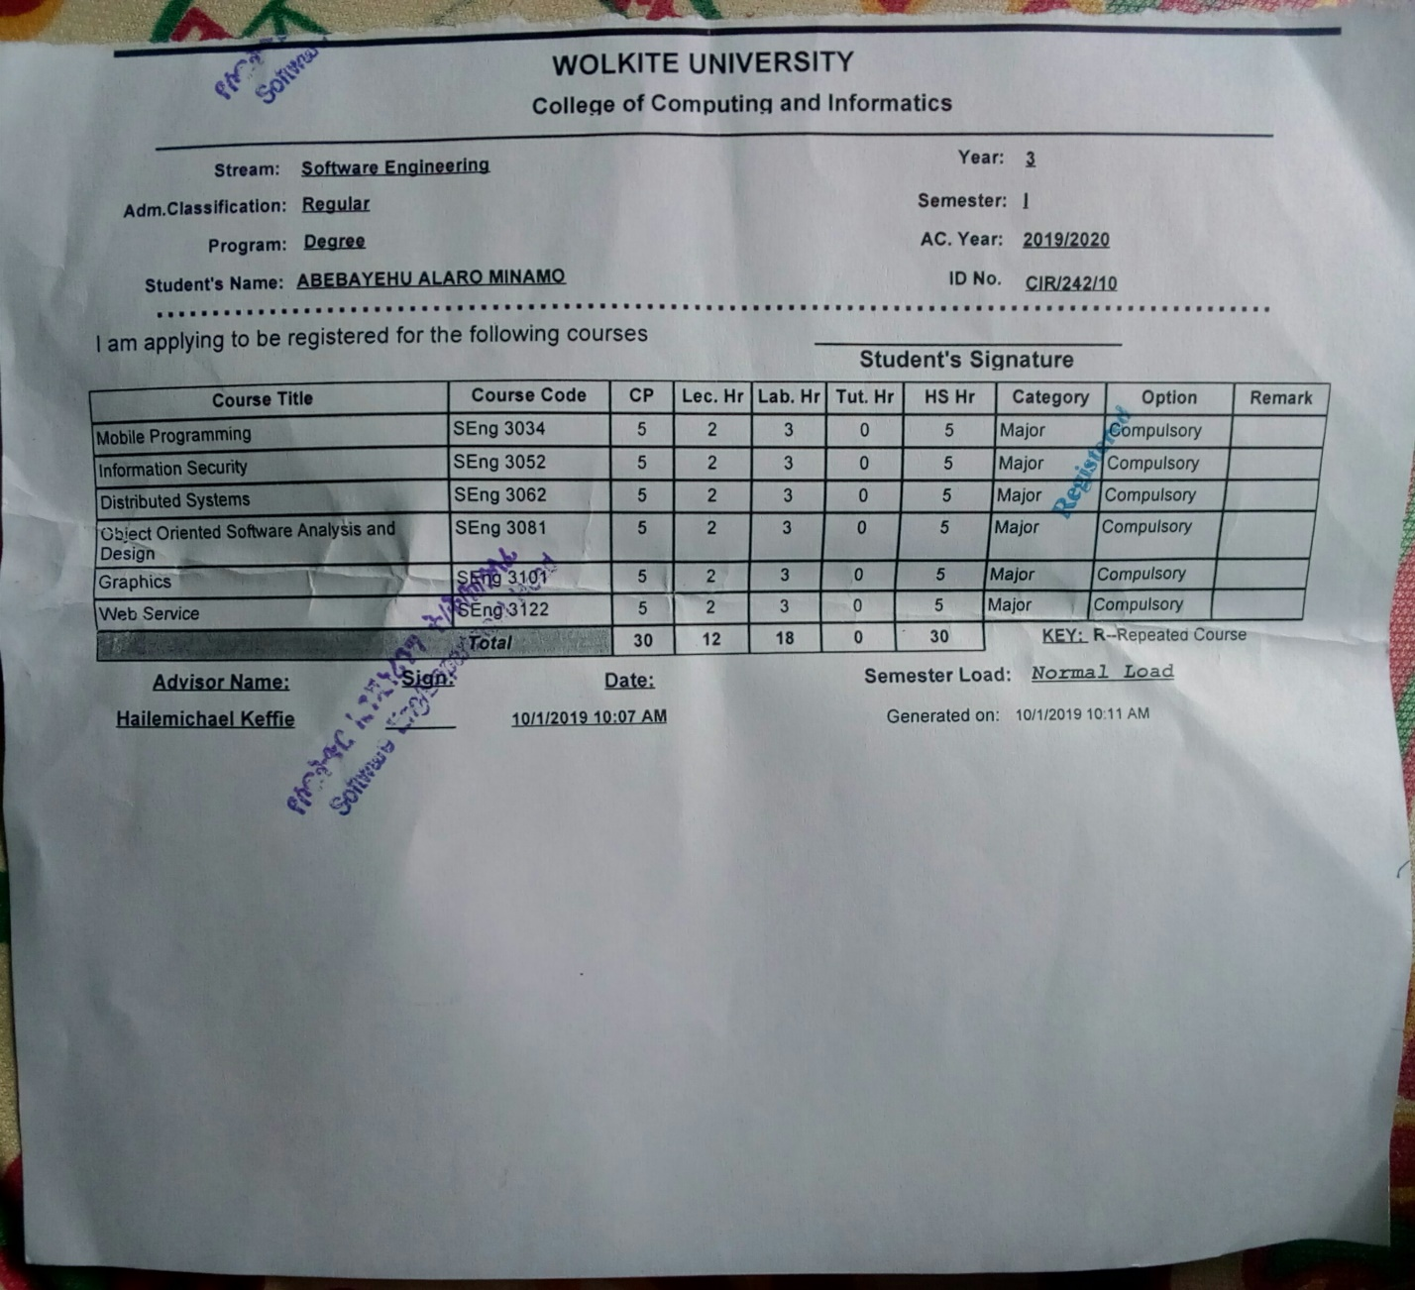

Fig 2.1. Screenshot of the Course Registration Form

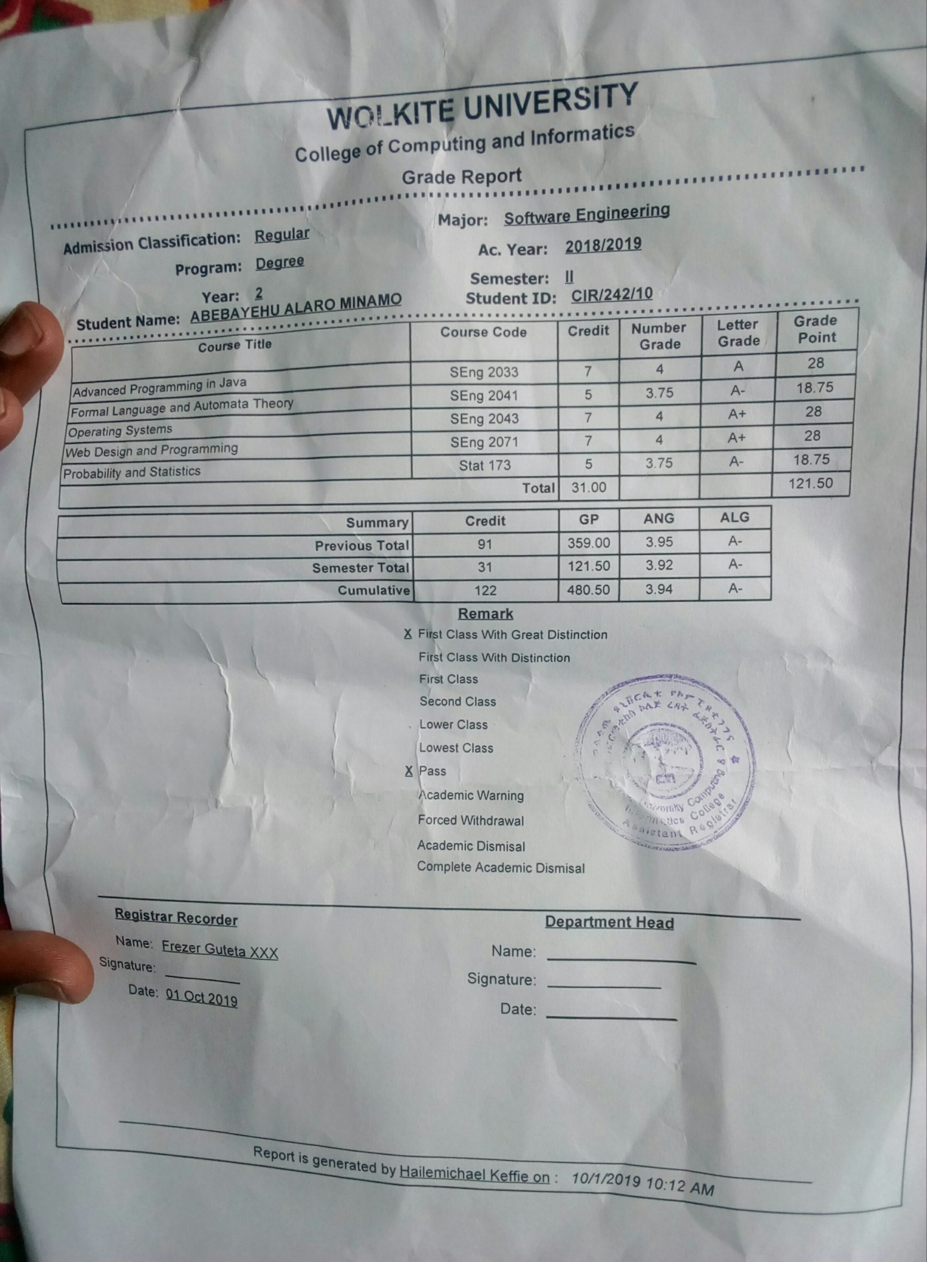

Fig 2.2. Screenshot of the Grade Report Form

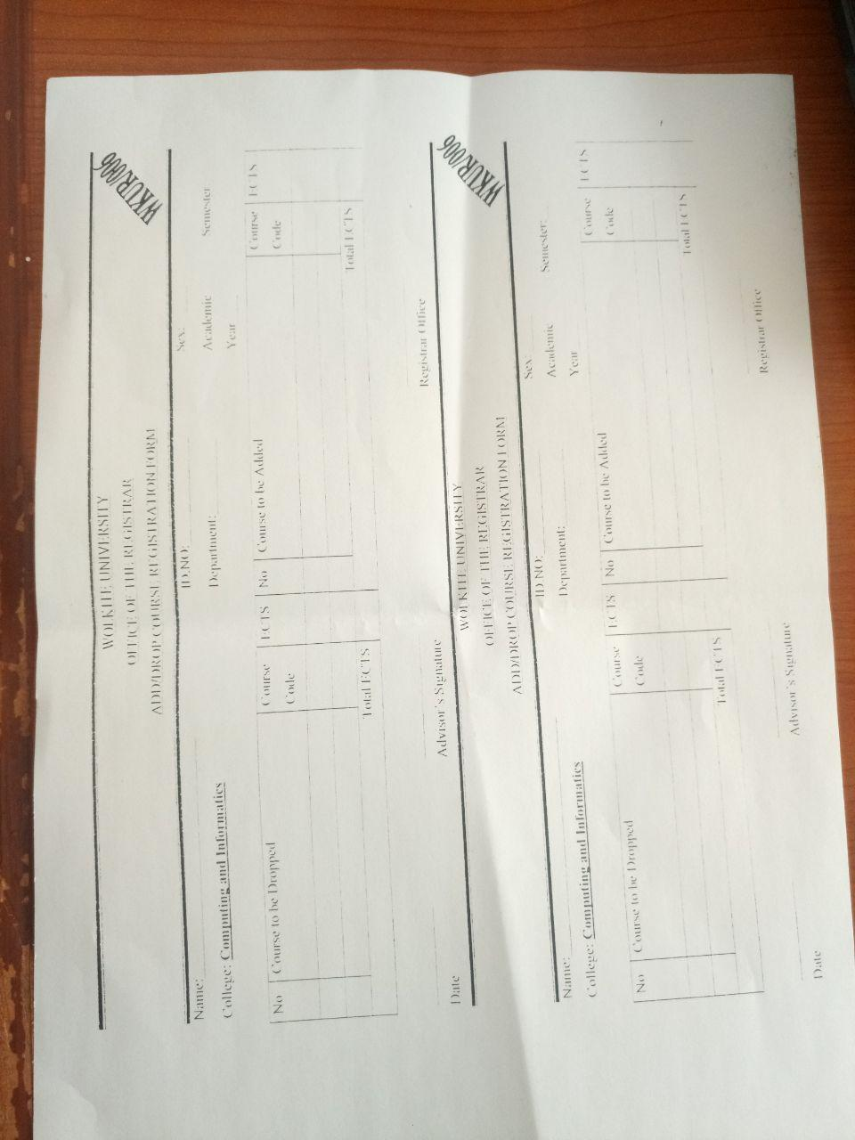

Fig 2.3. Screenshot of the Add/Drop Course Form

## **Drawbacks of the Existing System**

### **Performance**

#### **Response Time**

Since the registrar office performs student registration, slip, grade report, add/drop courses, searching and data retrieving mechanism of the system manually, its response time is low. The following are the reasons why the response time of the current system is low:

* The students fill their biography into the registration form manually due to that there are several queues to take and submit the registration form. The current system (SIMS) has no online student registration portal.
* The grade report is given to the students through the paper at the end of each semester so there is no means to view/check their assessment as they need. The current system (SIMS) has no online result processing portal.

### **Economic problem**

Since the current system operates semi-manually, it is not economically sufficient i.e. there is the high cost of creating physical archives and buying resources (paper for slip, grade report and related things), high cost of managing and archiving documents in a physical environment, and high cost for employers. When we see the above concept briefly, slip with thousands of copies is given to departments, registrar and each student, and grade report and registration form is prepared each semester with an unnecessary number of copies (wastage of material). To perform the above activities, several employers are needed. These thousands of copies of slip, grade report, and registration form should be organized in several physical archives. These physical archives have to be managed and placed in probably half of the offices. When we analyze the cost of these things, the current system is not economically sufficient.

### **Efficiency:-**

When mistakes are made or modifications are needed specifically for filling student registration form, the action must be redone rather than updating it. Since the current system (SIMS) has no means of ascertaining the correctness of course registration and grade report before it is validated by the proper body, occasionally there is incorrect generating of grade report. It has also no clear rule on discretionary probation (this rule will be discussed with business rule) as a result it occasionally leads to an incorrect decision. This leads the work efficiency to low.

### **Searching Problem:-**

Searching a record of a particular student from big fat registers, before the records entered into the system, is certainly a very time consuming and tedious task. This is because the search requires the managers to go through all the registers/ledgers and search the particular record from a set of thousands of records.

### **Security Problem:-**

Since the different information about the student is maintained in a register and stored in cupboards, shelves, drawers, etc. before it entered into the system. It is not at all secured from the crooks who would like to change it as per their advantage (especially related with mark) and it has no provision for backups in case of damage or loss of information (especially related with registration form).

## **Business Rules of the Existing System**

The following are the operating policy of the existing systems:-

### **User validation:**

To be able to use the software, users are to be registered by the Main Registrar with a default username and password on the first login to the software.

### **Grade Report:**

To generate the grade report, the grade report should be approved by the department head, college dean, and registrar consecutively.

### **Accountability of the users:**

Staffs are accountable to the department heads, department heads are accountable to the college deans and college deans are accountable to the higher officials.

|  |  |  |  |  |
| --- | --- | --- | --- | --- |
| Raw Mark  Interval-[100] | Corresponding Fixed Number  Grade | Letter Grade | Status description | Class description |
| 100-90 | 4.0 | A+ | Excellent | First class with Great destination |
| 89-84 | 4.0 | A |
| 80-84 | 3.75 | A- |
| 75-79 | 3.5 | B+ | Very good | First class with destination |
| 70-74 | 3.0 | B |
| 65-69 | 2.75 | B- | Good | First class |
| 60-64 | 2.5 | C+ | Second class |
| 50-59 | 2.0 | C | Satisfactory |
| 45-49 | 1.75 | C- | Unsatisfactory | Lower class |
| 40-45 | 1.0 | D | Very poor | Lowest class |
| 35-39 |  | FX |  | Lowest class |
| Below 34 | 0 | F | Fail | Lowest class |

Table 2.1. Grading Scale and Letter Grade System for Wolkite University

### **Description of the Grading System**

* A student who scored 'C' and/or "D" in a course/s can pass to the next semester if he or she has a pass mark in SGPA/CGPA/CANG.
* If the 'C' and/or "D" grade is for a Module or a course as a module, he/she must re-sit for another exam with self-study to remove ‘C’ and/or “D” when module Status determination is required.
* A student with good stand can pass to the next semester and even can graduate if he/she scores “D” and or “C” in any course under module, nevertheless, if the student is not good standing, he or she should re-sit an exam within two weeks after the beginning of the semester with self-study.
* A student who scored “F” in a course/module must repeat the course/module for the maximum of two-time. After that, if she/he repeat F grade, the student can request for course change/replacement or waiver as course allergic.
* The final grade of any repeated course shall be maintained regardless of the initial one.

### **Student Academic Achievements**

* At the end of each semester, the academic unit will examine the status of all students who are registered for the particular semester.
* One semester in the regular program is equivalent to two semesters in the evening program. The academic status evening student is, therefore, determined every other semester.
* For Kiremt programs, the academic status of the students shall be determined for a minimum of 25 ECTS points/15 credit hours.
* Grade report should be issued to applicants for semesters to which the status is determined by the CC/DA.
* The academic status of part-time students is determined for a minimum of 25 ECTS points/15 credit hours, starting from the first admission date of the students.

### **Academic Standing of Undergraduate Students**

A cut-off SANG/SGPA and/or a CANG/CGPA for status determination of all students shall be as follows:

### **Modular Courses**

* A first year student whose first semester SANG is >= 1.75 can pass to the second semester.
* A student who earned a 2.0 (C) grade or above in all courses of a semester shall be in good standing.
* A student cannot register a course for more than three times anyway. In case the student scores F after three times, article 50.5 will apply.
* If a student did not take supplementary examination having “Fx” within two weeks’ time due to unjustifiable reason, the “Fx” shall be converted into “F” for status determination.
* Any re-admitted student can repeat courses he/she scored “F”,”D” and or “C”.
* Any consecutive warning leads to Academic Dismissal.

A cut-off SANG/SGPA and/or a CANG/CGPA for status determination of all students shall be as follows:

### **First Year Students**

* A student who, at the end of the first semester, receives an SGPA/SANG of less than 1.50 shall be dismissed for academic reasons.
* A student, who, at the end of the first semester, scores a semester grade point average (SGPA/SANG) of 1.50 up to 1.74 both inclusive, shall be warned.
* A student, who, at the end of the first semester, scores a semester grade point average (SGPA/SANG) of 1.00 up to 1.49 both inclusive, shall be readmitted.
* If a student, who has been put on warning during the first semester, fails to maintain an SGPA/SANG of 1.75 or CGPA/CANG of 2.00 during the second semester of the first academic year, he is subject to dismissal unless otherwise put on probation at the discretion of the academic commission.
* A student, who, at the end of the second semester, receives either an SGPA/SANG of less than 1.75 of CGPA/CANG of less than 2.00 shall be warned.
* If student’s SGPA/SANG is less than 1.75 and his CGPA/CANG is less than 2.00, the student is subject to dismissal.
* If a student fails to achieve a SGPA/SANG of 1.00 at any semester, he/she is subject to dismissal.

### **Second and Higher Class Year Students**

* A student, who fails to achieve either SGPA/SANP of at least 1.75 and/or a SGPA/CANG of at least 2.00 at any semester, shall be wanted by his dean. However, a student who fails to achiever SGPA/SANP of 1.00 at any semester is subject to dismissal.
* A student for a second consecutive semester scores either an SGPA of less than 1.75 or fails to maintain a SGPA/CANG of 2.00, is subjected to dismissal unless put on probation. A student who is subject to dis missal cannot claim probation as a matter of right.

### **Discretionary Probation**

* The function of discretionary probation, with can only be granted by the respective Academic Unit, is to allow students who fall below the required academic standards to continue their studies. The decision to permit a student to continue his/her studies on discretionary probation is based on individual consideration of his/her case and a conclusion that, in view of all the relevant circumstances, there prevails a reason to believe that the student can raise himself/herself academically to the required level of achievement.
* At the end of the semester, each academic unit, pursuant fixed by its CC/DA, will examine the case of each student who is subject to dismissal due to academic deficiency. The inquiry will attempt to determine why the student failed and whether there is reason to believe that he’/she will meet the required academic standards within the remaining study period of the student, As a result of this inquiry, students may be placed on probation if it is determined by the respective CC/DA that:

a) Valid reasons exist to explain their low academic performance.

b) Those causes for their academic deficiencies can be removed.

c) The students can attain the required academic standard during the same semester in which they have been put on probation.

* A CC/DA of particular academic unit may attach certain condition to grant a probation, which must be met if the students are to remain enrolled.
* When students are placed on probation, their head of the academic unit will notify of their status and what is expected of them in their academic performance and what will be the consequence of the failure to meet these requirement in the future.
* Even so, a student shall be dismissed after placed on warning for one semester and on probation for another consecutive semester if he/she doesn’t removed himself/herself from probation by attaining a CANG/CGPA of 2.00.

# **CHAPTER THREE**

# **3. PROPOSED SYSTEM**

## **Functional Requirements**

Functional requirement explains and describes the interaction between the system and the users or in general with the environment. Functional requirement determines what the system can do as well as input and output of the System. The proposed system is expected to provide course registration and result processing related functionalities like course registration, and result processing. In order for a better understanding of our system, we divided the functionalities of our system by modules. The new system is expected to provide the following functionalities:

### **User Module**

### **Registrar Staff (Admin)**

* The system shall enable the admin to register the students, staff (Instructors), head of departments, dean of colleges, and registrar staff.
* The system shall enable the Admin to create the new semester in the beginning of the academic calendar that has three cycles each year – Spring (First Semester), Summer and Fall(Second Semester). The new semester to start is automatically selected by the system.
* The system shall enable the admin to remove all the previous pending registration requests.
* The system shall enable the Admin to remove grading (result) details for the offered courses completed before the new semester.
* The system shall enable the Admin to post the students’ result to the students.

### **Dean of College (DOC)**

* The system shall enable the Dean of College to approve the grade reports of students in his / her college.
* The system shall enable the Dean of College to view the students’ result of his/her college.
* The system shall enable the Dean of College to control the course assessment progress of his/her college.

### **Head of Department**

* The system shall enable the Head of Department to add course for a new semester from the existing list of courses, and assign students in individual units of the Department according to their batches.
* The Head of Department selects the semester and course name, and enters section, maximum seats and course outline for this course.
* The system shall enable the Head of Department to edit the course(s).
* The Head of Department enters the details for the offered course which includes quizzes, assignments, projects, tests, and final weights.
* The Head of Department assigns a staff to a course by selecting the name of staff, role and control.
* The Head of Department shall select the batches who can view the course while registering online.
* The system shall allow the Head of Department to remove the course(s) from the offered list of courses for the new semester.
* The system shall allow the Head of Department to view the course list, the students result, and to control the assessment progress in its department.

### **Student**

* The System shall enable the students to register courses, edit registered courses, and print registered courses.
* The system shall enable the students to fill their biodata.
* The System shall allow the student to view all his/her results together with the GPA for the semester.
* The system shall allow the student to view his/her registration status.
* The system shall allow the student to select courses he wants to add.
* The system shall allow the student to drop course(s) from the registered course(s) list of the current semester.
* The system shall allow the students to view all added/dropped course request status.
* The system shall enable the student to view his/her registered, added, and dropped courses in the current and previous semester.

### **Staff**

* The system shall enable the staff to enter students’ scores for the courses he /she teaches.
* The system shall enable the staff to view all the students’ results in his unit.

### **Control and Check Module**

* Any semester already registered cannot be registered again and won’t be visible in the list of semesters available.
* The system shall not display any course to the student whose pre-requisite has not been studied by the student.
* The system shall not allow the student to perform online registration after the registration deadline. The registration then becomes disabled on the student view.
* The system shall not allow the student to add more courses than his registration limits.
* The system shall enable the student to view a list of courses from his previous semesters, which he/she can or should repeat. It includes all the courses with grade F and GPA C- or less.
* The system shall not allow the staff to enter the mark that greater than from a particular assessment weight. For example if a staff inserts 6 in a place of an assessment that weighted 5, then the system displays some message rather than storing it.

### **Registration Module**

* The system shall provide an interface to the students where they can place online registration requests.
* The system shall display a list of courses from which the student can perform registration**.**
* The system shall display list of all courses that the student has withdrawn and are being offered in the current semester.
* The system shall display the biodata registration form to the students.
* The system shall display on the form student’s semester, program, identification number, name, and year on the student view.
* The system shall display a message to the student once his registration request has been submitted.

### **Result Processing Module**

* The system shall provide an interface to the staffs where they can insert the students’ score.
* The system shall provide an interface to the students to view their results (such as assessment, final, GPA, CGPA, and etc.) that they have taken.
* The system shall calculate the CGPA and GPA of the students based on the entered score according to the business rule.

### **Report Module**

* The system shall generate a report about how many students are registered, added and dropped courses.
* The system shall also generate a report about how many students are got ‘F’,’Fx’, and ‘NG’.

## **Non-functional Requirements**

Non-functional requirement describes the user-visible aspects of the system that are not directly related to the system and not designated to functional behavior of the system and it deals with the additional quality of the system. Such as the following: -

### **User Interface and Human Factors**

Automated course registration and result processing system will provide a user friendly and easily understandable interface as a result the users of the system can easily use and perform their needs. The proposed system will use common layouts and user controls, and consider the spatial relationships between items on the page and structure the page based on importance.

The users of the proposed system are arranged from low leveled expertise to high level expertise and most of them are familiar with web based applications as a result there is no complexity to use the proposed system since it is a user friendly system.

### **Hardware Consideration**

The proposed system should run on any computers and any android-based smartphones that support a web browser since it is a web based system. Moreover, our automated course registration and result processing system can run in any modern hardware devices.

### **Security Issues**

Public networks such as the Internet do not provide a means of secure communication between entities. Communication over such networks is susceptible to being read or even modified by unauthorized third parties. The proposed system shall use the Cryptography that helps to protect data from being viewed (ensure data confidentiality), provides ways to detect whether data has been modified (ensure data integrity), and helps provide a secure means of communication over otherwise non secure channels. For example, in the proposed system the data can be encrypted by using a cryptographic algorithm, transmitted in an encrypted state, and later decrypted by the intended party. If a third party intercepts the encrypted data, it will be difficult to decipher.

Since we use ASP.NET to develop the proposed system, our system shall use the following cryptographic algorithms that provided by ASP.NET framework to ensure the different security goals.

Data privacy:

* AES

Data integrity:

* HMACSHA256
* HMACSHA512

Digital signature (Non-repudiation):

* ECDsa
* RSA

Key exchange:

* ECDiffieHellman
* RSA

Random number generation:

* RNGCryptoServiceProvider

Generating a key from a password:

* Rfc2898DeriveBytes

### **Performance Consideration**

The proposed system will have easy, efficient code manipulation, and clear database. Average load time of the starting page of the system should be less than 2 seconds. Thus, the response time of the system will be very small.

The system will support more than one users (concurrent users) at a time since it is web based system. Therefore, our system performs action a much faster.

### **Error Handling and Validation**

In most cases the errors that will face the users will be user input related and SQL exceptions. In order to handle these errors, the system will check user inputs to the system. If there is the user input related errors, then the system handles and shows error in a user friendly manner, without overstressing the user. We handle this errors in client side by using JavaScript validator. If the error type is SQL exception, then it will be handled by the backend tool MySQL and the error message will display to the users in a user understandable mode. We use front end validation to reduce the loading time of pages. If there is any server-side error, it is only visible on the developers log to the system admin, they are not visible to the user. All the users will be notified that there was a server error. All the detail will be kept in the logs for the developers.

### **Quality Issues**

The proposed system is available anywhere and whenever i.e. the users who use the internet can access it with any web browsers at any time he/she needs. The system is also reliable due to the system is highly secured.

### **Backup and Recovery**

We aimed to store our backup data in other trustful backup and recovery place such as cloud, and other databases. We store the copy of our database into another database and cloud whenever the data enters into it because the data that stored on it is the critical ones. If the system unfortunately fails, we easily recover the data from that database and cloud.

### **Physical Environment**

Once the system is developed, it will be deployed on Wolkite University server because automated course registration and result processing system is mainly aimed to help the students of Wolkite University.

### **Documentation**

Automated course registration and result processing system has well defined document (user documentation), which guides the users how to use the system. We will also prepare a technical documentation that helps the maintainers to easily maintain the system.

# **CHAPTER FOUR**

# **SYSTEM ANALYSIS**

System analysis is conducted for the purpose of studying a system or its parts in order to identify its objectives. It is a problem-solving technique that improves the system and ensures that all the components of the system work efficiently to accomplish its purpose. Analysis model contains three models: functional, object and dynamic models. The functional model can be described by use case diagrams. Class diagrams describe the object model. Dynamic model can also be described in terms of sequence, state chart and activity diagrams. For the purpose of this project, we have described the analysis model in terms of the functional model and dynamic models using use case, sequence diagrams, Activity diagram, State diagram, and class diagram

## **System Model**

To describe the abstract models of our system we use the following use case model with each of this use case model presenting of developing abstract models of the system. We can represent our system by using different system models such as use case models, object models, dynamic models, that describe the problem to be solved and as system models represented by graphically, they are more understandable than more detailed natural language description of the system requirement

### **Use Case Model**

The Use Case Model (use case diagram, use case description, use case scenario) is used to define the core elements and processes that make up our system. This Use Case Model capture the functional system components. Because Use Case Models are simple in nature, this Use Case Models are a great way to storyboard flows with users and define the system requirements being modeled and help write the scenarios later used in testing.

#### **Use Case Diagram**

Use case diagrams are used for capturing functional requirements of the system. It is the functionality of the system or the service provided by the system. In use case diagram it better to consider the following elements.

• Use case - which is the functionality of the system which directly interacts with the user

• Actor - anything which interacts with the system.

• A relationship between the use cases.

In this system we identified both actors and use cases (functionalities) as the following:

* DOC
* HOD
* Admin
* Staff
* Student

#### **DOC**

* DOC can log in into the system and log out from the system
* Dean of College can approve the grade reports of students in his / her college.
* Dean of College can view the students’ result of his/her college.
* Dean of College can control the course assessment progress of his/her college.

### HOD

* HOD can log in into the system and log out from the system
* Head of Department can add course for a new semester.
* HOD can assign students in individual units of the Department.
* The Head of Department selects the semester and course name, and enters section, maximum seats and course outline for this course.
* Head of Department can edit the course(s).
* The Head of Department can enter the details for the offered course which includes quizzes, assignments, projects, tests, and final weights.
* The Head of Department can assign a staff to a course.
* The Head of Department shall select the batches who can view the course while registering online.
* Head of Department can remove the course(s) from the offered list of courses for the new semester.
* Head of Department can view the course list.
* Head of Department can view students result.
* Head of Department can control the assessment progress in its department.

### Admin

* Admin can log in into the system and log out from the system
* Admin can register the students,
* Admin can register staff (Instructors),
* Admin can register head of departments,
* Admin can register dean of colleges,
* Admin can register registrar staff.
* Admin can post the student’s result.
* Admin can update session

### **Student**

* Student can log in into the system and log out from the system
* Student can register courses
* Student can edit registered courses
* Student can print registered courses.
* Student can fill her/his biodata.
* Student can view all his/her results.
* Student can view request status.
* Student can add courses.
* Student can drop course(s)
* Student can view his/her registered courses.
* Student can view added courses
* Student can view dropped courses.

### Staff

* Staff can log in into the system and log out from the system
* The system shall enable the staff to enter students’ scores for the courses he /she teaches.
* The system shall enable the staff to view all the students’ results in his unit.

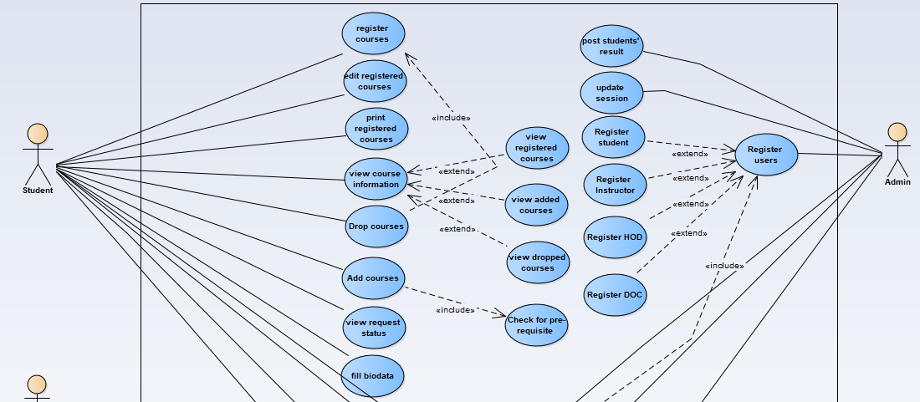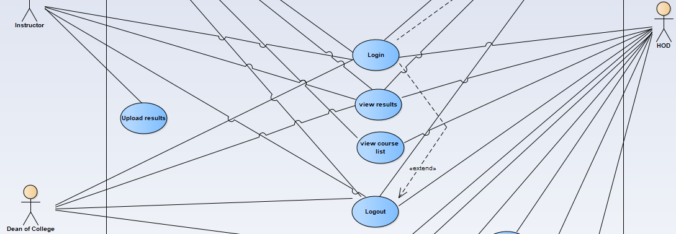

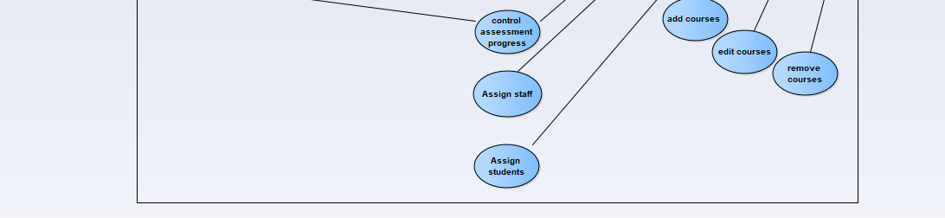

Figure 4.1 use case diagram



### **Use Case Description**

The use case description is used to detail description of the use case what and how the use case works in order to perform user and system functionality. In this project, we discussed detail use case description as shown the following tables.

|  |  |
| --- | --- |
| Name | Login |
| Identifier | UC 01 |
| Description | Enters a registered user in to the system. |
| Actor | Admin, Student, Staff, HOD, DOC |
| Precondition | The user should be registered |
| **Basic Course of Action**: | 1. User click on (login) link on the home page  2. The System display login page.  3. User fulfills the username and password and then click on (login) button  4. The System validates entered value.  5. Now the user has access to his account (logged in).  6. The System display account page.  7. End use case. |
| **Alternate Course** | 4.1.user enters invalid username and password  i. The System displays messages that contain “field cannot be empty or you entered wrong username or password” will be displayed.  ii. User repeat number 3 from the **Basic Course of Action**. |
| Post condition | The user will have access to his account. |

Table 4.1 Login use case description

|  |  |
| --- | --- |
| Name | Register staff, HOD, DOC, and student |
| Identifier | UC 02 |
| Description | The student adds course if it has no prerequisite |
| Actor | Student |
| Precondition | The student is logged in to the system. |
| **Basic Course of Action**: | 1. Student clicks add course link on the home page 2. The system verifies the student has no prerequisite course according to business rule. 3. The System displays add course page 4. Student fulfills the information that the system request and click on add course button 5. The System validates entered value from the Student. 6. The system will add course and display successfully added message. 7. The System display home page. 8. Use case end |
| **Alternate Course A** | The Student Does Have the Prerequisites  A.3. The system determines the student is not able to add course he chose.  A.4. The system informs the student he has the prerequisites course. |
| **Alternate Course B** | The student enters invalid information  B.5. The system determines the student enters invalid information  B.6. The System displays a messages that contain “field cannot be empty or you entered a wrong value” will be displayed.  ii. Student repeat number 4 from the  **Basic Course of Action** |
| Post condition | Login into the system and do another activity. |

Table 4.2. User registration use case description Table 4.3.view result use case description

|  |  |
| --- | --- |
| Name | View result |
| Identifier | UC 03 |
| Description | results that are posted by the Admin |
| Actor | Admin, student, HOD, DOC ,and staff |
| Precondition | Users should be registered. |
| **Basic Course of Action**: | 1. User clicks on view result link on home page.  2. The System displays generated result.  3. User view notification  4. Use case end |
| **Alternate Course** | Nothing |
| Post condition | Get important information |

|  |  |
| --- | --- |
| Name | add course |
| Identifier | UC 04 |
| Description | . |
| Actor | Student |
| Precondition | Browse Course Registration and Result Processing website |
| **Basic Course of Action**: | 1.Admin clicks register link on the home page  2. The System displays registration page  3. Admin fulfills the information that the system request and click on register button  4. The System validates entered value from the Admin.  5. The system will register user and display Successfully registered message.  6. The System display home page.  7. Use case end |
| **Alternate Course** | 4.1. The user enters invalid information  i. The System displays a messages that contain “field cannot be empty or you entered a wrong value” will be displayed.  ii. User repeat number 3 from the  **Basic Course of Action** |
| Post condition | Login into the system and do another activity. |

Table 4.4. Add course use case description

* 1. **Object Model**

An object model is a logical interface, software or system that is modeled through the use of object-oriented techniques. It enables the creation of an architectural software or system model prior to development or programming. In our system we use object model like class diagram and data dictionary.

* + 1. **Class Diagram**

In software engineering, a class diagram in the Unified Modeling Language (UML) is a type of static structure diagram that describes the structure of the system.



### **Data Dictionary**

A data dictionary is a file or a set of files that contains a database's metadata. The data dictionary contains records about other objects in the database, such as data ownership, data relationships to other objects, and other data. In our Course registration and Result Processing system the following table describe data dictionary.

Table name: Student

Primary key: studentId

|  |  |  |  |
| --- | --- | --- | --- |
| Attributes | Data type | Data Size | Constraint |
| studentName | String | 30 | Not null |
| studentId | String | 30 | Primary key |
| studentEmail | String | 30 | Not null |
| studentPhoneNumber | String | 14 | Not null |
| natioanality | String | 30 | Not null |
| region | String | 30 | Not null |
| zone | String | 30 | Not null |
| woreda | String | 30 | Not null |

Table name:result

Primary key :studentId

|  |  |  |  |
| --- | --- | --- | --- |
| Attributes | Data type | Data Size | Constraint |
| studentName | String | 30 | Foreign key |
| studentId | String | 30 | Primary key |
| final | double | 30 | Not null |
| assessmentScore | double | 30 | Not null |
| grade | char | 30 | Not null |
| courseCode | String | 30 | Foreign key |
| semester | String | 30 | Not null |

## **Dynamic Model**

A dynamic model represents the behavior of an object over time. It is used where the object's behavior is best described as a set of states that occur in a defined sequence. In our system we use sequence diagram, activity diagram, and State diagram.

### **Sequence Diagram**

A Sequence diagram is an interaction diagram that shows how processes operate with one another and in what order. It is a construct of a Message Sequence Chart. A sequence diagram shows object interactions arranged in time sequence. It depicts the objects and classes involved in the scenario and the sequence of messages exchanged between the objects needed to carry out the functionality of the scenario so in Course registration and Result Processing system website there will be different process to do specific actions and we include some sequence diagrams to handle these interactions.

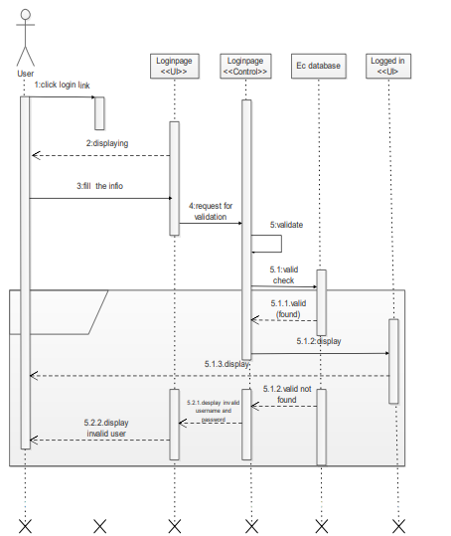

Figure 4.3. Login sequence diagram

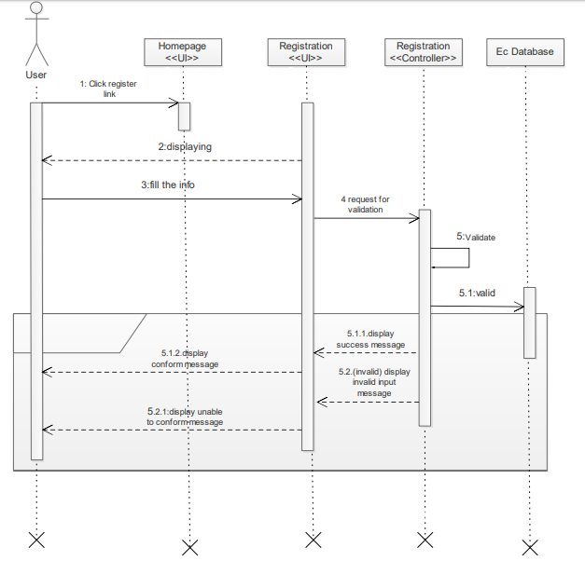

Figure 4.4. Register sequence diagram



Figure 4.5 Add course sequence diagram

### **Activity Diagram**

Activity diagram is basically a flow chart to represent the flow form one activity to another activity. The activity can be described as an operation of the system in order to perform many tasks there should be one or more activity to be done. From figures 4.12 to figures 4.14 below are our system activity diagram



Figure 4.6 Activity diagram for Admin Side

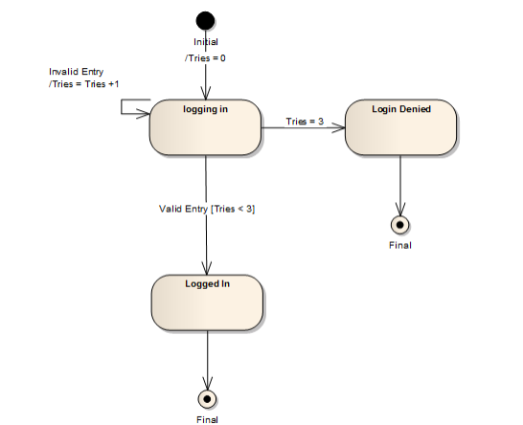

Figure 4.7. Activity diagram for login

### **State Chart Diagram**

State chart diagram describes the flow of control from one state to another state. States are defined as a condition in which an object exists and it changes when some event is triggered. So, the most important purpose of State chart diagram is to model life time of an object from creation to termination whenever performing different activities there will be some states that are included in activities so in our project Course registration and Result Processing system website we have listed below some states that can be covered during the user interacts with the system. Figure below from figure 4.15 to figure 4.21 describe the state diagram of our system.

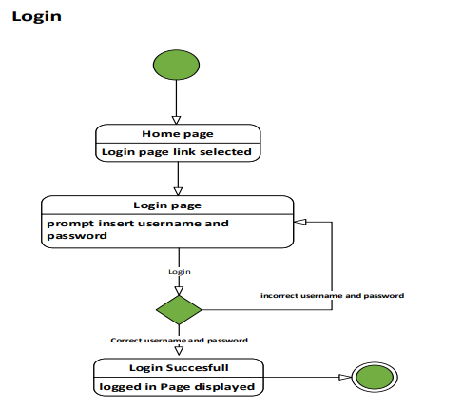

Figure 4.7. Login start chart diagram

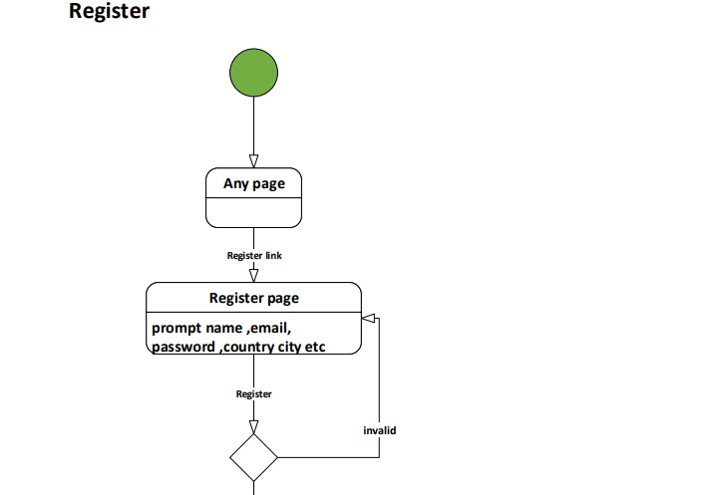

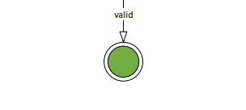

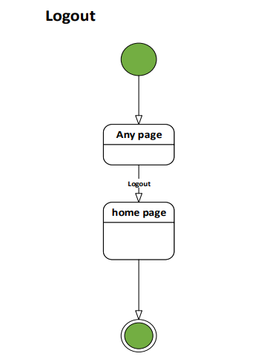

Figure 4.9. Logout start chart diagram

# **CHAPTER FIVE**

# **SYSTEM DESIGN**

System design is the transformation of the analysis model into a system design model. Design is process of describing, organizing, and structuring system components at architectural design level and detailed design level. Course registration and Result Processing system design overview is proposed solution for existing system problem through proposed system. Our proposed system is divided into different categories in order to the complexity of system when we providing a solution for the specific problem.

## **Design Goals**

Design goals are targets for design work. These are typically agreed upon by stakeholder as the criteria for comparing design alternatives and evaluating design outcomes. The objectives of design are to model the system with high quality. The design goals are derived from nonfunctional requirements that means non-functional requirement is the description of the feature characteristics and attribute of the system as well as any constraints that may limit the boundary of the proposed system. The Design Goals specify the qualities of the system that should be achieved and addressed during the design of the system. The following are illustrative examples of design goals.

### **Accessibility**

This system is available for 24 hours a day since it is web based system. So it can be accessed everywhere and time.

### **Integrity**

The system Commits transactions that are completed and/or rollback unfinished or time-out transactions. It validates the type of data that is going to be processed. It defines what the fields can accept as input, like text, image, file, video and other types. Then it should have processed the users want based on the input data. The system should integrate these inputs with database.

### **Scalability**

The system can be modified to higher system by adding some components or by using as one component in another system.

### **Availability**

This system is business solution so that it is critical to keep availability in high priority. The system should always be available for access at 24 hrs.7 days a week. Also in the occurrence of any major system malfunctioning, the system should be available in 1 working days, so that the business process is not severely affected.

### **Throughput**

Throughput of the system should be considerably adequate to provide a continuous service for the customers. The number of transaction the system performs at a given branch of the company should be at least 500 per second.

### **Robustness**

Since the system is a web-based system that mainly uses a menu driven access there would not be an input problem by the user side. But for the server side there might be an error during the process of entering a data. In this time the system will provide an error page and the system will continue without failure or affection.

### **Security**

The system should be secured, i.e., not allow unauthorized users to access the database system.

**Reliability**

The information provided by the system is as reliable as it is presented on the web page interface, and this is maintained by the persistent database.

### **Maintenance**

Maintenance: - In time of failure or need modification the system needs to be maintained. To be maintainable the system should meet the following maintenance criteria.

• Extensibility: - If it is needed to add new functionality to the system, this must be achieved by only making a separate page and integrate this page with the existing system.

• Modifiability: - If in the system, some functionality requires to be modified, this modification must be done specifically to that function or page without affecting the overall system organization.

## **Design Trade-offs**

### **Security vs Usability**

Possible have lots of reason for selecting security instead of usability but again our system considers usability besides security. Relating security issues our system will drown line for each user which functionality of the system need to access by authenticate finally, record each users of the systems’ information including the task they have done on that specific date, also securing data during transfer is one of task our system handles additional to others security matter.

### **Functionality vs Usability**

The system favors usability compared to functionality yet it doesn’t mean that the system loses its proper functionality. Rather the developing team will endeavor to maintain the basic requirements of the system along with high usability. The system will avoid lavish functionalities, which are not a must for the system’s existence, for the sake of encouraging basic system utilization.

### **Performance vs portability**

The system selects portability compares to performance but not say our system does perform his task with low performance that annoy every user rather the system performs its operation without depending specific type of operating system as a result of this users can install the system any place where ever it needed without bother a kind of plate form, they going to use.

## **Proposed System Architecture**

The system was designed in a 3tier architecture. The 3-tier architecture comprises of:-

(1). **The Presentation Tier:** - This software level presents the user with the interface. It was designed with a HTML.

(2). **The Middle Tier:** - This level serves as an intermediary between the interface and the database. It picks data entered by the user through the interface and either inserts it into the database or compares with the already existing data in the database

(3). **The Data tier:** - This is the third tier of the software architecture. It is the database that allows the insertion, storage and retrieval of any information.

### **Subsystem Decomposition and Description**

System decomposition is the process by which a complex system is broken down into parts that are easier to conceive, understand, program, and maintain. It breaks a large system down into progressively smaller classes or objects that are responsible for some part of the problem domain. Components are generally units of computation or data stores in the system. A component has a name, which is generally chosen to represent the role of component or the function it performs. The different components of a system are likely to interact while the system is in operation to provide the service expected of the system. In our system the following subcomponent is available.

**Administrator subsystem**-- responsible for handling action that administrator performs.

* Login
* Logout
* Register the students,
* Register staff (Instructors),
* Register head of departments,
* Register dean of colleges,
* Register registrar staff.
* Post the student’s result.
* Update session

**HOD subsystem**-- responsible for handling action that HOD performs.

* Login
* Logout
* Add course
* Assign students.
* Selects the semester and course name, and enters section, maximum seats and course outline for this course.
* Edit the course(s).
* Enter the details for the offered course which includes quizzes, assignments, projects, tests, and final weights.
* Assign a staff to a course.
* Select the batches.
* Remove the course(s).
* View the course list.
* View students result.
* Control the assessment progress in its department.

**DOC subsystem** -- responsible for handling action that DOC performs.

* Login
* Logout
* Approve the grade reports.
* View the students’ result.
* Control the course assessment progress.

### **Student subsystem** -- responsible for handling action that Studentperforms

* Login
* Logout
* Student can register courses
* Edit registered courses
* Print registered courses.
* Fill biodata.
* View results.
* View request status.
* Add courses.
* Drop course(s)
* View registered courses.
* View added courses
* View dropped courses.

### **Staff subsystem** -- responsible for handling action that Staffperforms

* Login
* Logout
* Enter scores.
* View results.



Figure 5.1 Subsystem Decomposition

### **Hardware/Software Mapping**

One of the major tasks in system design deals with hardware/software mapping which deals with which components would be part in which hardware and so on. It shows the relationships between the software and hardware components in the system and the physical distribution of the processing using deployment diagrams. A deployment diagram shows what hardware components exist, what software components run on each node, and how the different pieces are connected. Deployment diagram also used to show the hardware of the system, the software that is installed in the hardware and also the middleware that is used to connect the disparate machines to one and other



Figure 5.2. Deployment diagram

### **Detailed Class Diagram**

Detail class diagram is class diagram that include attributes, methods, attribute data types, visibility of attributes and methods, inheritance, association, aggregation, composition, dependency, and municipality (cardinality and optimality). The following figure, uses the UML class diagram to specify attributes and operations with their visibility information.



Figure 5.3. Detail class diagram

### **Persistent Data Management**

This describes the persistent data stored by the system and the data management infrastructure required for it. This section typically includes the description of data schemes, the selection of a database, and the description of the encapsulation of the database. The interaction of table during retrieve or fetch data from the database and mapping from class to table by using reference key or foreign key.

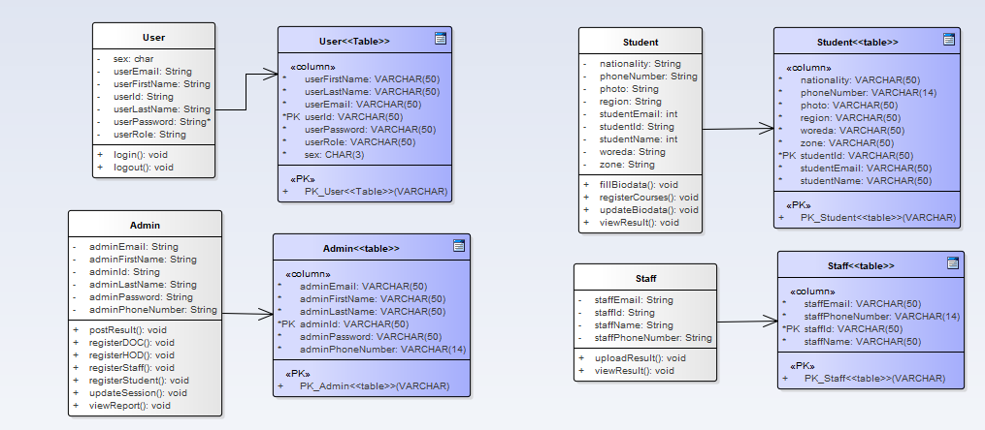

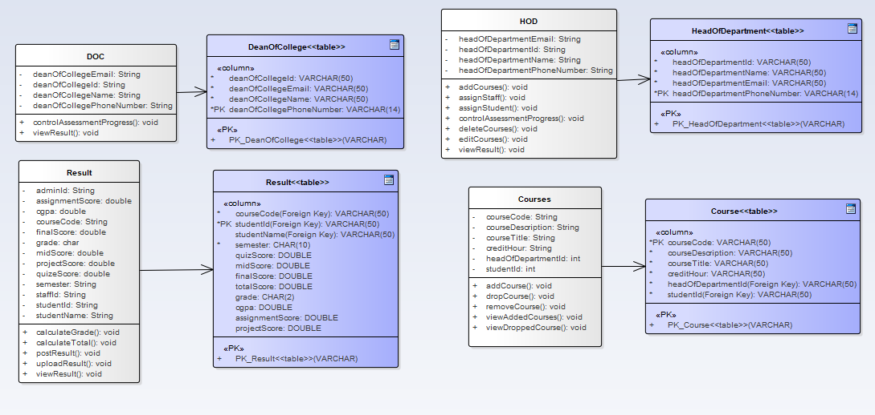

Figure 5.4. Persistent diagram

## **User Interface Design**

User interface design (UI) or user interface engineering is the design of user interfaces for machines and software, such as computers, home appliances, mobile devices, and other electronic devices, with the focus on maximizing the user experience. The goal of user interface design is to make the user's interaction as simple and efficient as possible, in terms of accomplishing user goals (user-centered design) so in our project Course registration and Result Processing system we have designed user interfaces that increase the user experience.

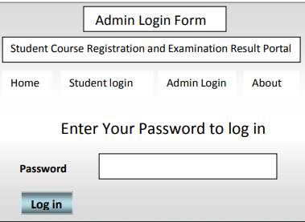

Figure 5.5. Admin Login Form

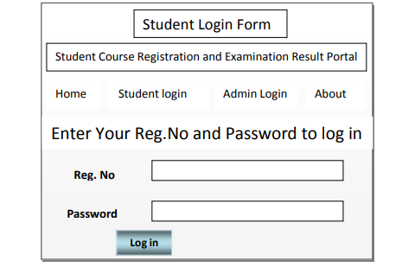

Figure 5.5. Student Login Form

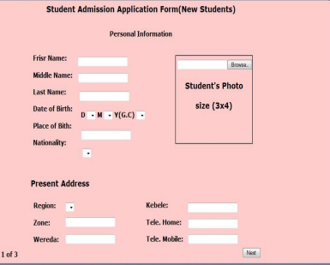

Figure 5.6. Student Biodata Filling Form

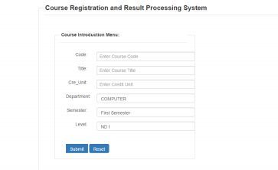

Figure 5.6. Add Course Form

# **REFERENCES**

BOOKS:

Ermiyas Birhanu (MSc.), Worku Muluye (MSc.) Zerihun Mulugeta (MSc.) W. M. (2018). WKU Reviewed Project Guideline Version 4 (2). wolkite: wku.

(Systems Analysis II, Domain Modeling,)

(System Analysis and Design Object Oriented Approach)

(The_Object_Primer_-_Agile_Model-Driven_Development_with_UML_2.0)